neo MOTLOUNG, ST10538987, LECTURE: LWAZI, WEDE5020
[Document subtitle]
30 March 2026
SWEET CRUMBS BAKERY
54Nota street Phake section
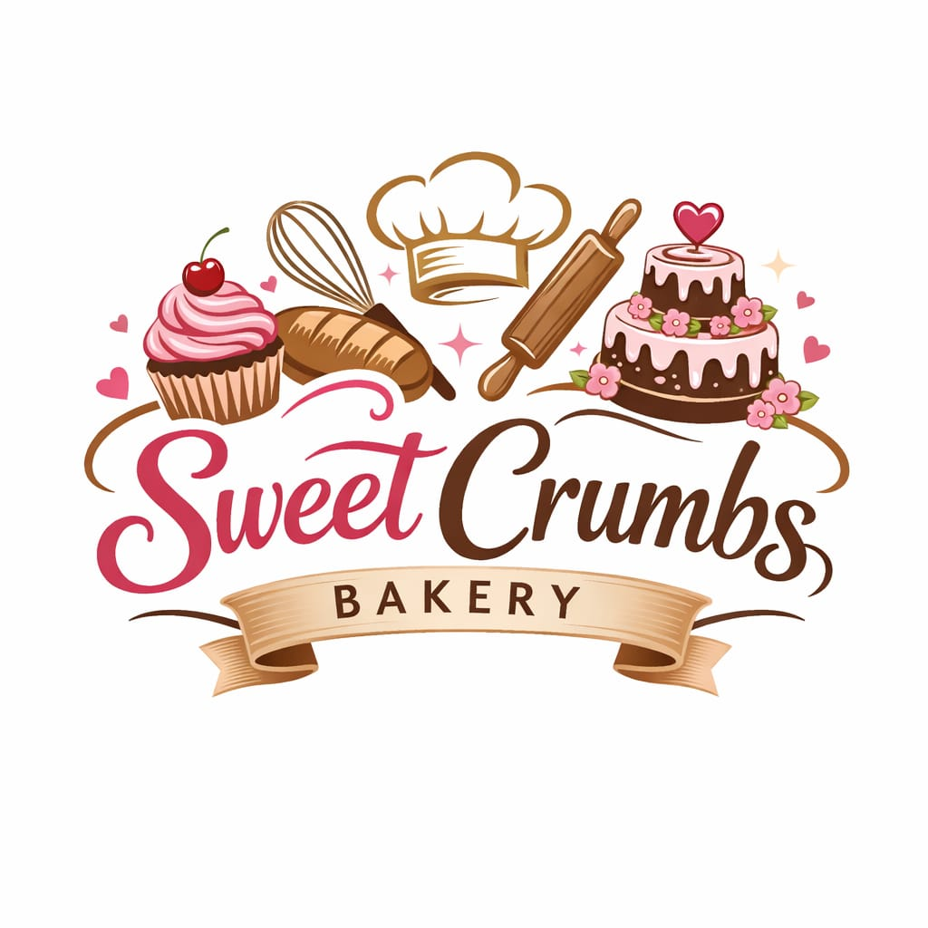

Contents
1. Organization Overview 1
2. Website Goals and Objectives 1
2. Website Goals and Objectives 2
3. Current Website Analysis 2
4. Proposed Features and Functionality 2
5. Design and User Experience 3
6. Technical Requirements 3
7. Timeline and Milestones 4
8. Budget Estimate 4
9. References 4

1. Organization Overview
Name: Sweet Crumbs Bakery
Sweet Crumbs Bakery is a small local business that specializes in freshly baked goods such as cakes, pastries, and breads. The bakery was established to serve the local community with high-quality, freshly made products using traditional baking methods. Over time, it has gained popularity through word-of-mouth and a loyal customer base.
Mission: To deliver fresh, delicious baked goods while providing excellent customer service.
Vision: To become a recognized and trusted bakery known for quality, creativity, and consistency.
Target Audience:
- Local residents
- families
- students
- event customers (birthdays, weddings)
- walk-in and online customers

2. Website Goals and Objectives
- Goals:
• Establish an online presence
• Provide business and contact information
• Showcase products and services
• Attract new customers
• Promote special offers and events
- Key Performance Indicators (KPIs):
• Increase in website traffic
• Growth in social media engagement
• Increase in sales and orders

3. Current Website Analysis
Currently no website exists.
- Opportunities:
• Create a professional digital presence
• Improve accessibility for customers
• Reach a broader audience beyond the local area

4. Proposed Features and Functionality
- Pages:
• Home Page
• About Us
• Products/Services
• Gallery
• Contact Page
• Order/Enquiry Form
- Features:
• Mobile-friendly and responsive design
• Easy and intuitive navigation
• Contact form for customer inquiries
• Integration with social media platforms
• Display of business location and operating hours

5. Design and User Experience
- Design Style:
• Clean and modern layout
• Warm and welcoming appearance
- Color Scheme:
• Cream
• Soft pink
• Light brown
- Typography:
• Simple and readable fonts
• Decorative fonts for headings
- User Experience:
• Easy navigation between pages
• Fast loading speed
• Clear call-to-action buttons
• Visually appealing product User Experience:
• Easy navigation between pages
• Fast loading speed
• Clear call-to-action buttons
• Visually appealing product images

6. Technical Requirements
- Hardware Requirements:
• Computer or laptop for development
• Smartphone for testing responsiveness
- Software Requirements:
• Web browser (Google Chrome, Microsoft Edge)
• Code editor (Visual Studio Code)
• Design tools (Canva or Figma)
- Technologies Used:
• HTML for structure
• CSS for styling
• JavaScript for interactivity
- Hosting Requirements:
• Web hosting service
• Domain name (e.g., www.sweetcrumbsbakery.com

7. Timeline and Milestones
- Week 1: Research and proposal approval
- Week 2: Content collection
- Week 3: Website Design
- Week 4: Website Development
- Week 5: Testing and improvement
- Week 6: Final Submission

8. Budget Estimate
- Domain name: R10–R5 per year
- Web Hosting: R50–R100 per year
- Design Tools: Free or up to R10
- Development Cost: R0 .00(student project)
- Total Estimated Cost: R60-R125

9. References
- W3Schools. (2024).HTML, CSS, and JavaScript Tutorials.
- MDN Web Docs (2024), Web Development Resources.
- Canva (2024). Design Resources.
- Google Fonts. (2024). Free Fonts Library.

